DISCOVERING VALUE & FORM
- VALUE is the range from light to dark.
- FORM is an element of art that is described as 3-dimensional (having height, width and depth) and which encloses volume (i.e. cylinders, cubes, spheres, etc.)
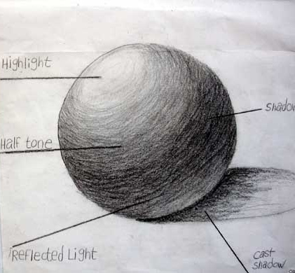
ELEMENTS OF SHADING:

1. BLACK (Cast shadow)
2. DARK GRAY (shadow)
3. MEDIUM GRAY (half tone)
4. LIGHT GRAY (Reflected Light)
5. WHITE (Highlight/Full light)

GOALS: Create TWO SPHERES:
Black and Gray Sphere showing at least 5 values and the elements of shading.

Color Sphere blending at least 3 different colors such as red-yellow-and blue or red-orange-yellow depicting at least 5 values and elements of shading.

Each sphere has to show a proper light source.

Label at least one sphere with the elements.

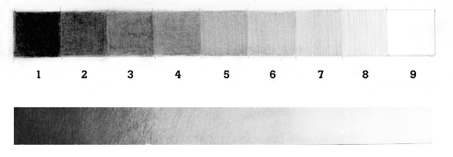A value scale shows the change to light to dark.
GOALS: TWO VALUE SCALES
Your value scales can be made with boxes or can be free form (organic), Each value scale needs to demonstrate (AT LEAST) 5 values.
One Color value scale
One Black and Gray
EXTRA CREDIT:
Create different shapes using different directions of a light source.
Create an op art illusion using value.
Try to create value scales and create form with objects using different techniques (Ex: Cross Hatching, Stippling, Lines) and tools ( Ex: Ball point pen, oil pastel, marker) H – B pencil range.

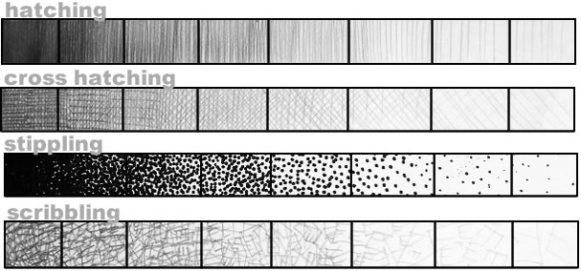
There are two graphite grading scales used to measure the hardness of a pencil’s graphite core.
NUMERICAL GRAPHITE SCALE: The first graphite grading scale is a numeric scale. Using this scale, the hardness of the core is often marked on the pencil — look for a number (such as “2″ “2-1/2″ or “3″). The higher the number the harder the writing core and the lighter the mark left on the paper. As the pencil core becomes softer (through the use of lower proportions of clay) it leaves a darker mark as it deposits more graphite material on the paper. Softer pencils will dull faster than harder leads and require more frequent sharpening.
HB GRAPHITE SCALE: The second graphite grading scale is known as the HB scale. Most pencil manufacturers outside of the U.S. use this scale, using the letter “H” to indicate a hard pencil. Likewise, a pencil maker might use the letter “B” to designate the blackness of the pencil’s mark, indicating a softer lead. The letter “F” is also used to indicate that the pencil sharpens to a fine point.
Historically, pencil makers also use combinations of letters — a pencil marked “HB” is hard and black; a pencil marked. A 4B would be softer than a 2B and a 3H harder than an H.
GRAPHITE SCALE COMPARISONS: Generally, an HB grade about the middle of the scale is considered to be equivalent to a #2 pencil using the U.S. numbering system.
Finding what works best for your own artistic and writing needs is generally a matter of personal preference and experimentation with different brands of pencils.
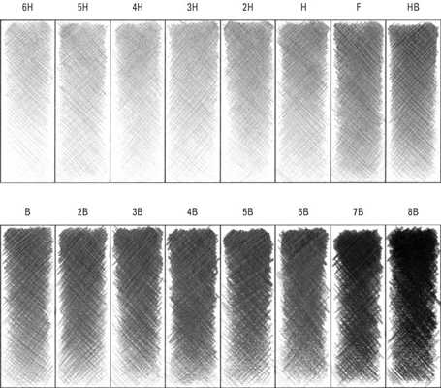

EXTRA CREDIT PRACTICE SHADING WORKSHEET
